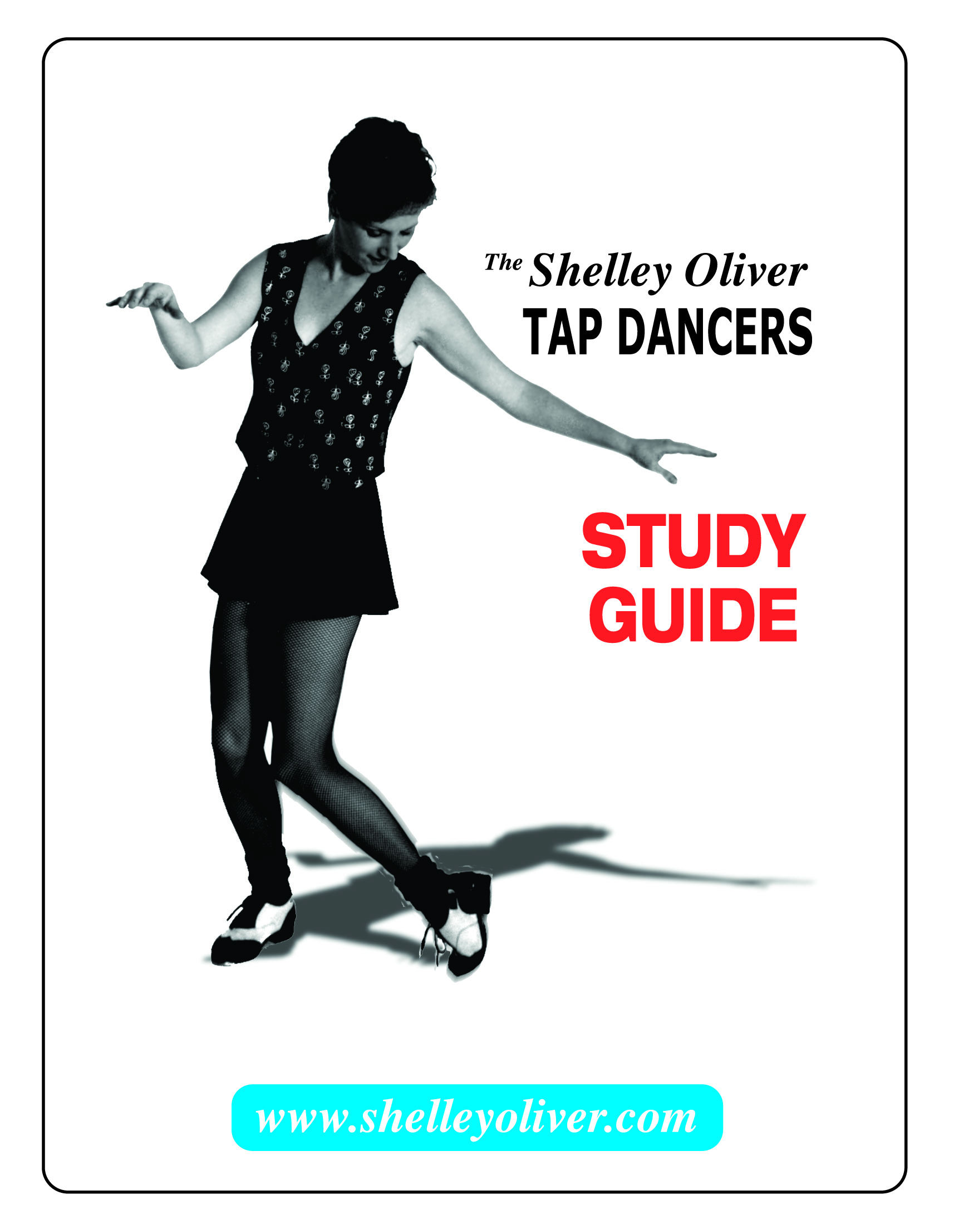

ABOUT THE ARTISTS

Shelley Oliver, artistic director of The Shelley Oliver Tap Dancers is a tap dancer, choreographer and educator. She has appeared internationally with some of the legends in the tap world. She is a founding member of the New York City based dance ensemble Manhattan Tap and has toured extensively throughout Europe, China, the Caribbean, Canada, and the United States.

Her television appearances include Tap Dance in America with Gregory Hines and Star Search. Ms. Oliver has appeared with tap notables Savion Glover, Jimmy Slide, Buster Brown, Steve Condos and Chuck Green. She has also performed with renowned jazz musicians Slide Hampton, David “Fathead” Newman, Robin Eubanks, and Kenny Washington.

She has developed interactive tap dance presentations for Lincoln Center, New York City Public Schools, and various school districts in the US. She also conducts workshops and master classes nationally and university dance programs have commissioned her choreography. She teaches jazztap at Muhlenberg College and is the Director of the Muhlenberg Jazztap Ensemble providing a community outreach program in the Allentown area. She has developed and conducted a “Tap and Math” program for elementary students and special needs groups.

The Shelley Oliver Tap Dancers are a high caliber ensemble of three women rhythm tap dancers with wide scale audience appeal. Accompanied on stage by The David Leonhardt Jazz Group, the dances are rhythmically driven and an expression of Ms. Oliver’s musical and visual ideas.

True to the traditions of both jazz music and jazz tap dancing, the performances include dynamic improvisational elements, synchronized ensemble dancing and stunning solo work. Each dancer in the ensemble is a strong soloist skilled in jazz tap improvisation and there is a dynamic interaction among dancers and musician that develops during each performance. This gives each dancer and musician the chance to express their personal style and artistic vision.

The David Leonhardt Jazz Group is an acoustic ensemble that plays a blend of mainstream and modern jazz. Led by pianist David Leonhardt, the group has appeared internationally in concert halls, festivals and night clubs. Composer and musical director for The Shelley Oliver Tap Dancers, Mr. Leonhardt has over thirty years experience working with the some of the best tap dancers in the world including Savion Glover. He has performed with Stan Getz, Herbie Mann, Jon Hendricks and David “Fathead” Newman.
ABOUT THE SHOW

The concert will feature performance of a variety of tap dances accompanied by live music and interactive demonstrations throughout. Students will learn about the indigenous history of jazztap and see examples of original choreography and historic routines. They will learn about choreography and improvisation and participate in rhythm games. Throughout the presentation the artists will be striving to inspire and educate on aspects of jazztap dancing through an engaging format tailored for the age of the audience. Following the show, time will be given for students to ask the artists questions.

ABOUT JAZZTAP

What is it?

Jazztap dancing, also known as rhythm tap, is a form of dancing where the focus is on the creation of rhythm by the dancer’s feet. While it can also be vey visual and pleasing to watch, the dancer is primarily a percussionist. Jazz music and jazztap dancing grew up together in America in the early 20th century and influenced one another. “Jazztap” refers to the jazz based rhythms created by the tap dancer. The term also distinguishes it from the Broadway style of tap dancing where the focus is more often on the visual arrangement of steps and appearance of the dancers.

Where did it come from?

Tap dancing was invented in America but it derives from West African ideas about drumming and dance. When slaves arrived from Africa they brought their ideas of dancing barefoot, stomping to complicated drum beat rhythms. Dancers would “challenge” one another with displays of strength and expertise and improvise dance moves and steps. When slave owners took their drums away, these musicians and dancers experimented with other ways to produce rhythms. Mingling with other cultures such as Irish immigrants who performed step dancing and jigs, African dancers began to duplicate their footwork but to a jazzier rhythm. Tap dancing was born and developed as an art form keeping the West African ideas about improvisation and challenge.

Vaudeville and Hollywood

Tap dancing eventually found its way into Vaudeville theaters in the late 1800’s. As tap dancing became more popular it entered movies sets, jazz clubs, and Broadway during the 1920’s, 30’s, and 40’s. In big theatrical shows and musicals the dancing became less and less about the rhythm and relied more heavily on the look of the dancer and costuming. The chorus line was created where the dancers (usually all women) danced the same steps in a line at the same time. At the jazz clubs however tap dancers were developing their own individual styles and turning the form into jazztap with rapid footwork and complex rhythms.

Jazztap Today

Tap dancing grew to popularity in the 1930’s, becoming the most popular dance form in America. However as television became the favored entertainment for Americans and rock and roll dominated popular music, interest in tap dancing declined in the 1950’s. For decades tap dancing went underground with many jazztap dancers out of work. In the 1970’s, young tappers rediscovered it by mentorship and study with the original African American tap dancers, masters of this art form.

Today jazztap is thriving and moving in many directions-electrified and synthesized, combining with hip-hop and street dance as well as in concert halls and on Broadway. Tap dancing has captured the imagination of mainstream America. May 25th was proclaimed National Tap Dance Day by congressional vote in 1989. It is celebrated nationally with a variety of festivals and dance events.

BEFORE THE SHOW: PLEASE REVIEW WITH YOU STUDENTS

Audience Etiquette

During any live performance it is important to give the performers your attention. Quiet and attentive behavior is appreciated because it allows the performers to focus and concentrate on the show. It is also important to remain seated during the performance as it allows other audience members to view the show without interruption and standing up may distract the performers. The appropriate way to show appreciation for the performers is to applaud.

Students should remember to:
- Become quiet and focus attention on the stage when the performance begins
- Stay seated throughout the show
- Clap when something is appreciated
Remember questions that may arise and ask during the question and answer period following the show.

BEFORE THE SHOW: VOCABULARY

Choreographer – person who creates the dances
Choreography – composition and arrangement of dance steps
Composer – person who creates music
Challenge – a call to test one performers “skill against another”
Historical – belonging to the past; as in historic dance routines
Improvisation – spontaneously creating steps, combinations or rhythms without a set routine
Jazztap – style of tap dance that focuses on the rhythm dancers make with their feet
Percussion – striking one thing against another, as with percussion instruments or drums
Rhythm – musical pattern of regularly recurring sounds or beats; like a heartbeat
Scat – nonsensical rhythmic vocalizations; often used by jazz singers as a vehicle for vocal improvisation
Unison – dancing the same steps together at the same time
Vaudeville – variety entertainment in theaters popular in the late 1800’s and early 1900’s

MUSIC FOR THE CLASSROOM

The music performed in the show can be downloaded from www.davidleonhardt.com or available from iTunes and CDBaby. The Tap Music for Tap Dancers series is especially designed for the study of rhythm and tap dance with a jazz feel, steady beats and a variety of songs. Volume 4. Hip Jazz for Hip Kids features children’s songs and is designed as a fun introduction to jazz. Please feel free to download some songs to enjoy in the classroom.

Suggestions:

Volume 1: Swingin’ Tappin’ & Jammin’ (Cute, Dave’s Shim Sham)

Volume 2: Smokin’ (Sweet Georgia Brown, Blues In The Night)

Volume 3: The Challenge (I Got Rhythm, Georgia On My Mind)

Volume 4: Hip Jazz For Hip Kids (Flintstones, Route 66)

Volume 5: Cool Tunes (Tuxedo Junction, Blues Shuffle)

Volume 6: Metal On Wood (Slippin’ Down, Shell’s Vamp)

Volume 7: Jammin’ Out (St. Thomas, Sunrise)

AFTER THE SHOW

Connecting to the Curriculum

The following ideas and exercises are suggested as ways to connect with the curriculum and maximize the learning experience the dance performance provides. After teaching dance classes for twenty-five years I have found many of the rhythm games effective and fun for students of all ages. Of course, please adapt them in any way you wish to accommodate your class.

*Rhythm in Nature
Use the idea of finding rhythm in ourselves and the world around us as a topic for group discussion. (Physiological rhythms of breathing and heartbeats, seasonal changes in nature and the rhythm of ocean waves, running and swinging on a swing, the rhythm of a basketball etc.) Generate a list and divide into groups and have each group choose 4 examples. Each group must then devise a way to mimic these rhythms. (For example clapping hands to the rhythm of a heartbeat, or swaying to they rhythm of ocean waves.) One group can try and guess the rhythms the other group is mimicking.

*Rhythm in Rhymes
Have the class recite a favorite nursery rhyme. Identify the rhythm of the verse by clapping while reciting it. Then clap the rhythm only. Try a few of these and then explore scatting the rhythm (ex. Da da da…) and stomping feet to it. Divide into groups and assign each a different way to practice it such as clapping or stomping etc. Each group can present their work.

*Variation: Street Rhyme
Assign each group their own nursery rhyme which they will keep secret. Students can try and guess each other’s rhymes by listening to the rhythm.

*Follow The Leader
This is a good game to do after completing some of the suggestions listed above. It can be done with the entire class or in smaller groups. Make a circle and choose one volunteer as the “leader”. The leader claps or stomps a short rhythm (4 beats) and the class has to repeat it back like an echo. Then try it with music. Change leaders often.

*Skip Counting
Divide the class into two groups. Have one group count to 8 over and over while clapping their hands on counts 2, 4, 6, and 8. The other group practices clapping on 1, 3, 5, and 7. Have each group demonstrate their counting and clapping. Try it with music keeping the counts on the beat. After some practice the groups can then perform it together at the same time.

*Variation For Skip Counting
Students generate 4 different ways to make percussive sounds or movement on their assigned counts such as stamping, snapping fingers or a body movement like jumping. They can then create a sequence by skip counting to 8 and executing a different move every time the do it. (For example, a final sequence for even number counting may be clapping on 2, 4, 6, 8, then stomping on 2, 4, 6, 8 then snapping on 2, 4, 6, 8, and the jumping on 2, 4, 6, 8.) Perform the sequence several times without stopping.

*Video Viewing
The videos listed in the reference guide are excellent sources of music and dance performance for the classroom. (Please view them before showing your class to determine age appropriateness.) The biological nature of them informs on American history and social trends. The noted dedication and contributions of the featured artist provides an inspiring role model. Questions following the viewing incorporate vocabulary words.

Shelley Oliver Tap Dancers YouTube links

The Shelley Oliver Tap Dancers Concert Highlights 3 &1/2 minutes http://www.youtube.com/watch?v=nc-XVQExQbc
Shelley Oliver Tap Master class http://www.youtube.com/watch?v=1hAIgMmoixY
Shelley Oliver Solo Dance “Starlight Interlude”
http://www.youtube.com/watch?v=dGpE6eESQBw
"Jazz And Tap For Kids" http://www.youtube.com/watch?v=8v692gtF1jw
The Shelley Oliver Tap Dancers “Reverberations”
http://www.youtube.com/watch?v=65NoT-J7UM4

Shelley Oliver solo Stop Time sequence
http://www.youtube.com/watch?v=B3V9FRLAjQQ

Shelley Oliver Ode To Bojangles
http://www.youtube.com/watch?v=XDEiIaAQQtg

Shelley Oliver Tap Dancers “Bedrock”
http://www.youtube.com/watch?v=4zPXa9o2p5s

Shelley Oliver Tap Dancers “Metal On Wood”
http://www.youtube.com/watch?v=PRLt_Zfl0LM

Shelley Oliver Tap Dancers “Funk Monk”
http://www.youtube.com/watch?v=uSuscvhOwus

Shelley Oliver Tap Dancers “Woodside”
http://www.youtube.com/watch?v=cUZJKw9nL30

INTERNET RESOURCES

The Shelley Oliver Tap Dancers
www.shelleyoliver.com
The David Leonhardt Jazz Group
www.davidleonhardt.com
History of Tap/Teaching and Workshops
www.offjazz.com
Events/Newsletters/Supplies/Other Tap Dance support Links
www.tapdance.org/tap
World Wide Arts Resources Webpage
http://wwar.com/catagories/dance/style/tap
Dance and Health
www.health.org/youritme.funactivities/art.asp

BOOK RESOURCES

JazzDance: The Story of the American Vernacular Dance
By Marshall and Jean Stearns (History)

JazzTap: From African Drums To American Feet
By Anne E. Johnson (History)

Inside Tap: Technique and Improvisation For Today’s Tap Dancer
By Anita Feldman (Instructional)

THE SHELLEY OLIVER TAP DANCERS

STUDY GUIDE ASSESMENT

Thank you for inviting The Shelley Oliver Tap Dancers to your school. Please take a moment to complete this evaluation following the performance and return it to the address listed on the last page. Your feedback will be helpful to us and is greatly appreciated.

- How many weeks in advance would you like to receive this Study Guide?

- When did you receive it in relation to the performance?

- Check the sections of the Study Guide used.

___ How to Be A Good Audience Member
___ About the Artists
___ About the Show
___ Vocabulary
___ Music for the Classroom
___ Connecting to the Curriculum
___ Further Resources

- What other materials would you like to see?

- If you didn’t use sections of the study guide, please indicate why.

- Did you discuss the performance during class?
___ Both before and after ___ After only
___ Before only ___ Not discussed

- To the best of your knowledge, what number of student sin your class had no previous experience with this art form?

- Please give any additional comments you think will be helpful to us.

- What subjects do you teach?
Grade level?
Number of students attending this performance?

Optional Information

Your name:
School:
Address:

Thank you for your time!
Please return this assessment to:

The Shelley Oliver Tap Dancers
90 Stage Coach Drive
Easton PA, 18042
Att: Shelley Oliver

